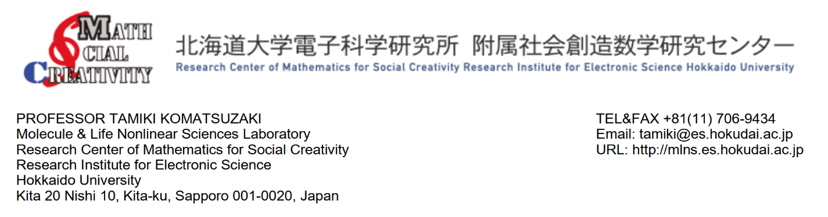 Date: October 18, 2022

To

The Registrar

Khulna University, Khulna-9208, Bangladesh

**Certification For Study Progress**

I am writing this letter as a progress status for the PhD study of **Md. Menhazul Abedin**, Assistant Professor, Statistics Discipline, Khulna University, Khulna-9208, Bangladesh. He joined in my lab as a PhD student under the **Graduate School of Chemical Sciences and Engineering, Hokkaido University, Japan**. He has successfully completed 4th semester (April 2022 – October 2022).

**Mr. Menhaz’s** research topic is the acceleration of designing chemical reactions and finding the target molecule whose property (such as drug efficacy and solvation affinity) is the highest using a reinforcement learning, linear bandit (Optimistic in the face of uncertainty linear bandit-OFUL) framework. Precisely, the objective of the research is to find the molecule including catalyst to own the highest/lowest quantity desired by chemists such as hydration free energy, and reaction enantioselectivity by fewer experiments as much as possible via bridging chemistry and information science.

For instance, to find molecules having lower hydration free energies is important because it implies the larger solubility of the molecules. His problem setting is here to find the lowest hydration free energy molecule by fewer experiments as much as possible using linear bandit algorithm. Linear bandit is an algorithm which assumes the contexts/object features are linearly related to a target (e.g., hydration free energy, reaction selectivity). Currently, he has developed a method based on the algorithm and evaluating the performance by using FreeSolv benchmark data, which contains experimental and calculated hydration free energies of 642 molecules. Well-known topological fragment’s features are used in the current analysis. However, having the cleaning steps, the total number of features are less than the sample size. Therefore, LASSO regression analysis is used for feature selection to cut away the irrelevant features.

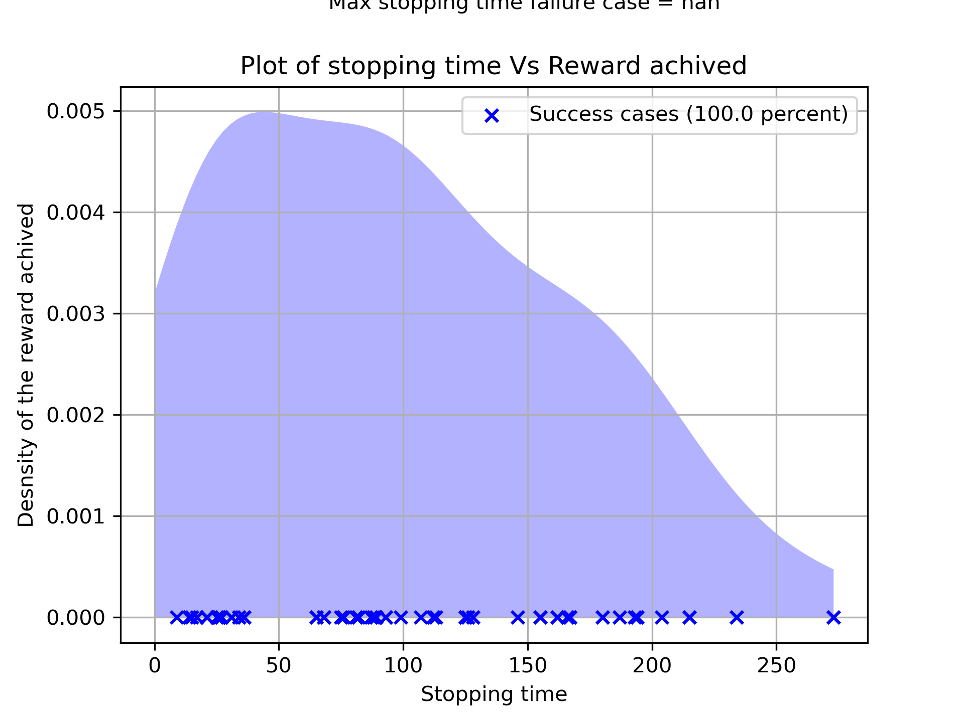

Fig 1: Stopping time distribution of success and unsuccess cases

Currently he defined a stopping condition based on upper bound “root mean square error (RMSE)” for the training set. Using the newly defined stopping condition the following results were observed. Fig. 1 shows that 100% of the episodes are successful, that is, the algorithm never stopped before finding the best molecule. Figure 1 also shows that all episodes are stopped within around 260 iterations before fully examining all 642 molecules.

**Poster presentation and conference attendance**

* Linear bandit algorithm for rapid search of high solubility molecules. The 60th Annual Meeting of the Biophysical Society of Japan. September 28-30, 2022. Hakodate, Japan.
* The annual Hokudai theoretical chemistry workshop 2022, August 22, 2022, Hokkaido University, Japan. (Only as participant)
* Linear bandit algorithm for rapid drug screening using topological features of molecules. FlyWorks Workshop 2022; August 7-9, 2022; Niseko, Hokkaido, Japan.
* Linear Bandit for Absolute Reward in Huge Feature Space. 22nd RIES-Hokudai International Symposium. Hokkaido University, December 6-7, 2021, Hokkaido, Japan.

**Research plan for the current year**

Methodology referring in an article of linear bandit algorithm does not use time-dependent feature depending on the progress of each episode, however in the current problem setting started with a very small set of initial molecules with time-dependent feature hence proving the theoretical part is new and important. Currently he is struggling to prove the theory. There is another direction of this research that can be extended like chemical interpretation of the features. And comparison of the newly developed method with traditional method is highly demanded.

Furthermore, he has started to write manuscripts. I believe that this year he will be able to publish the research.

For any query, please feel free to contact me. I wish him every success in his life.

**Best regards**

**Dr. Tamiki KOMATSUZAKI**  
Professor  
Hokkaido University, Japan  
E-mail: [tamiki@es.hokudai.ac.jp](mailto:tamiki@es.hokudai.ac.jp)